**Phase 2 Project2 Specification Use cases Sprints Final Submission.docx**

***This file is written with open-source LibreOffice Writer.***

***April 2023***

**Table of Contents**

Project Specification 2

Background 2

Git-hub repository link 2

Function Specification 2

Sprints Planning 3

Sprint1 3

Sprint2 3

Project code structures in Eclipse IDE 4

Java Core concepts used in the project 5

Inheritance 5

Encapsulation 5

“Do.. while” loop control for handling invalid inputs , 5

“Switch...case x” performs flow control of user choice in Menu 6

“Collection ArrayList” is used for filename processing, sorting, etc.. 6

“If {} else “ 7

Scalable code structures in class levels 7

Code re-use 8

Exception handling 9

Pre-defined class(es) are used 9

Simplicity and Informative User Interface: 9

Conclusion on enhancing the application and defining the Unique Selling Points 10

Flowchart 11

# **Project Specification**

# Background

**Airline ticket booking portal, FlyAway** is required for a budget approval for a company.

The application are required to interact with pubic flight ticket booking users and company internal system back-end administrator.

Developed by Steven Feng Situ ( [stevenfeng.situ@vodafone.com](mailto:stevenfeng.situ@vodafone.com))

Java FSD Phase 2 end project

April 2023

# Git-hub repository link

**https://github.com/SFS0001/Java-FSD-training-projects/tree/main/Phase%202%20Project**

# **Function Specification and Use cases**

Following functions are defined based on the requirements.

**1. Welcome homepage**

**1.1 Flight Search user input forms**

**1.1.1 Display available flight and price, expecting user select one flight**

**1.1.2 Register personal details**

**1.1.3 Display the selected flight details, expecting user processing payment**

**1.1.4 Payment gateway collects user payment details**

**1.1.5 Display payment confirmation and flight booking details**

**1.2 Back-End Admin Login page**

**1.2.1 Option to change admin password**

**1.2.2 Display list of available seats for the flight origin/destination**

**1.2.3 Display list of airlines**

**1.2.4 Display list of flights with origin, destination, airline and price**

# Sprints Planning

## Sprint1

Produce product function specification and use cases according to requirements

Development Works are documented in this document “**Phase 2 Project2 Specification Use-cases Sprints Submission Note-v0.2023xxx.docx”.**

Setup Git locally, GitHub version control remote repository and fully integrated between local development and remote server repository

Setup Eclipse IDE for Model View Controller (MVC) project type and design pattern.

<< resume from here >>

Welcome Main Menu (CLI/Console) and sub-menu of Business Operation, programming

Main flow control are established:

source codes :

**/src/com/WelcomeStartMenu.java**

**/src/com/BusinessOperation.java**

## Sprint2

- Develop codes for three business operations and return to Welcome menu, which forms the sub-menu of Business Operations Menu.

-- add a file

-- delete a file (case-sensitive)

-- search a file (case-sensitive)

-- close current context and exit to main context

-- close the application via Welcome menu

-- Demonstrate Java Core concepts and algorithms in application codes

ensuring all requirements are covered

This will be covered in the chapter of “**Core concepts used in the project”.**

-Welcome menu,

-- Application name and developer details

-- details of user interface , user interaction info.

-- accept user input to select one of the options

-- inputs out of range scenarios handing

- 1st user choice, return current file names in ascending order.

Root file can be empty or file or folder in it

- 2nd user choice,

a) add a file to existing directory list,

ignore the case sensitivity of filenames

b) Delete a file

case sensitive, exact match

Return message if FNF ( File not found)

(add-on feature: ignore existing directories , operating in files only )

c) Search a file

case sensitive on the file to retrieve the correct filenames

display the result on successful search

display not-success if that happened

Add-on features:   
 a. ignore existing directories , operating for files only

b. Display file last modification date and time, implying file creation time in this context

d) option to return back to main menu

Add-on feature, for all Operations, pause the flow for user to check the execution results,

let user to press ‘Enter’ to continue.

-3rd user choice,

close application

requirements, using Exceptions, Collections ,Sorting for sourcing code optimization and performance

Exception handling is integrated as part of the code, for example, file deletion , creation. Collection ArrayList is used for facilitate the sorting and searching of filenames.

Code is optimized by flow control and function categories, repeat method is called via inheritance for code re-use.

# Project code structures in Eclipse IDE

**Source-code files Function**

src/com/WelcomeStartMenu.java ---------- Welcome Menu

/BusinessOperation.java ---------- Business Operation Menu

/DeleteFile.java ---------- Delete a user specified file (case sensitive)

/ListFiles.java ---------- List files in ascending order

/SearchFile.java ---------- Search user specified file (case sensitive)

/AddFile.java ---------- Adding a user specified file (case in-sensitive)

FileStorage/dir-a test sub-directory   
 /dir-brc sub-directory   
 /aa1.txt test file   
 /... ....

# Java Core concepts used in the project

## Inheritance

Sub-class DeleteFile extends super-class SearchFile, to re-use the case-sensitive search method in super-class

**Code:**

*// subclass DeleteFile extends Super-class SearchFile for re-use the case-sensitive search method*

***public class DeleteFile extends SearchFile {***

## Encapsulation

**For security reason, Method deleteFile is protected, restricting calls from other package to delete a file.**

Code:

*// subclass DeleteFile extends Super-class SearchFile for re-use the case-sensitive search method*

***public******class*** *DeleteFile* ***extends*** *SearchFile {*

*//limiting access to deleteFile from other packages with protected method*

***protected void deleteFile () {***

*System.****out****.println("\nPlease enter the file name to delete: ");*

***System.out.println("----------------------------------------");***

## **“Do.. while” loop** control for handling invalid inputs ,

***do*** *{*

*System.****out****.println("Please enter your choice [1, 2,or 3]: ");*

*userChoice = sc.nextInt();*

***if*** *( userChoice!=1 && userChoice!=2 && userChoice!=3 )*

*{ System.****out****.println("\nYou entered ["+userChoice+ "] is out of range, please enter again.\n");*

*};*

*}****while*** *(userChoice!=1 && userChoice!=2 && userChoice!=3);*

## **“Switch...case x” performs flow control of user choice in Menu**

***switch****(userChoice) {*

***case*** *1:*

*//List filenames ascending order*

*// Call public class ListFiles for Option 1,*

*ListFiles pFilenames=* ***new*** *ListFiles();*

*pFilenames.printFilename();*

*// here should return to main menu*

*pressEnterToContinue();*

***break****;*

***case*** *2:*

*//Business operations*

*//do menu 2 list 2.1, 2.2, 2.3*

*BusinessOperation operations=* ***new*** *BusinessOperation();*

*operations.operationMenu();*

***break****;*

***case*** *3:*

*// Exit application , choice 3*

*//exiting the application*

*System.****out****.println("......\nGood Bye, thanks for using!");*

*System.exit(0);*

***break****;*

## **“Collection ArrayList” is used for filename processing, sorting, etc..**

***Code*** *// define an collections ArrayList arFilename for filenames, prepare for sorting*

*ArrayList<String> arFilename=* ***new*** *ArrayList<String>();*

***for*** *(* ***int*** *i=0; i < listFiles.length; i++)*

*{*

***if*** *(listFiles[i].isFile()) // exclude directory, only files allowed to be added to ArrayList*

*{*

*arFilename.add(listFiles[i].getName()); //get the filename by getName without absolute path*

*}*

*}*

*//Sorting ascending with Collections class sort*

*Collections.sort(arFilename);*

## **“If {} else “**

**condition flow control is used for dealing with “empty file directory” scenario:**

*//Printout the list with the help of Object i*

***if*** *(arFilename.size()==0) // If there is no file, print no-file information*

*{*

*System.****out****.println("\nThere is no file in this directory.");*

*}*

***else***

*{*

***for*** *(Object i : arFilename) // use Object i to printout ArrayList arFilename in vertical ascending order*

*{*

*System.****out****.println(i.toString());*

*}*

*}*

*System.****out****.println("-------------------------------------------------------------------"); //print footer*

*}*

## Scalable code structures in class levels

future add-on function can be easily expanded without change the main flow-control structure:

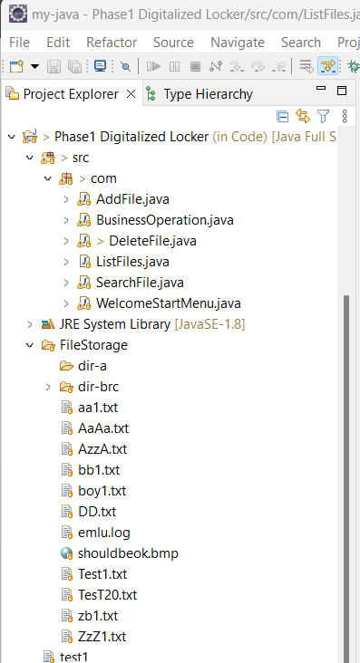

## Code re-use

**Search-File method of Search-File class is re-used for Delete-File class, which first locates the user specified file, prior to perform deletion.**

***public******boolean*** *CaseSensitiveSearch(String fileName) {*

***boolean*** *fileFound =* ***false****;*

*//filename with full path*

*String filePath="C:\\Users\\Daniel\\Documents\\Feng\\JavaFullStack\\Training\\Java Full Stack Developer Program-Steven Feng Situ\\Phase 1 Project\\Code\\FileStorage";*

*String filePathAndName="C:\\Users\\Daniel\\Documents\\Feng\\JavaFullStack\\Training\\Java Full Stack Developer Program-Steven Feng Situ\\Phase 1 Project\\Code\\FileStorage\\"+fileName;*

*File fP =* ***new*** *File(filePath);*

*File fPname =* ***new*** *File(filePathAndName);*

*//define Array listFiles storing list of file path and name*

*File[] listFiles = fP.listFiles();*

*// define an collections ArrayList arFilename for filenames, prepare for filename match test*

*ArrayList<String> arFilename1=* ***new*** *ArrayList<String>();*

***for*** *(* ***int*** *i=0; i < listFiles.length; i++)*

*{* ***if*** *(listFiles[i].isFile()) // exclude directory, only files allowed to be added to ArrayList*

*{ arFilename1.add(listFiles[i].getName()); //get the filename without absolute path*

*}*

*}*

*// define and initiate file finding result flag, fFound*

***int*** *fFound =0;*

***for*** *(Object i : arFilename1) // use Object i to test ArrayList arFilename with user specified filename*

*{* ***if*** *(fileName.equals(i.toString()))*

*{*

*fileFound =* ***true****;*

*}*

*};*

***return*** *fileFound;*

*}*

**In deleteFile class,**

***/ / Inheritance from super class SearchFile for re-use the method CaseSensitiveSearch***

*// SearchFile sf = new SearchFile();*

***if*** *(CaseSensitiveSearch(fileName))*

*{*

*// delete the file if exact match true*

***try*** *{*

***if*** *(fPname.delete())*

*{ System.****out****.println("\n"+fileName+" is deleted.");*

*}* ***else***

*{ System.****out****.println("\n"+fileName+" exists, but cannot be deleted.");*

*}*

*}* ***catch*** *(Exception e )*

*{ e.printStackTrace();*

*}*

*}*

***else***

*{*

*System.****out****.println("\n"+fileName+" is not found, no deletion!");*

*};*

*}*

## Exception handling

**(try.. catch) is used to capture any exception during file deletion:**

*// delete the file if exact match true*

***try*** *{*

***if*** *(fPname.delete())*

*{ System.****out****.println("\n"+fileName+" is deleted.");*

*}* ***else***

*{ System.****out****.println("\n"+fileName+" exists, but cannot be deleted.");*

*}*

*}* ***catch*** *(Exception e )*

***{ e.printStackTrace();***

## Pre-defined class(es) are used

**import** java.io.File;

**import** java.util.ArrayList;

**import** java.util.Collections;

**import** java.text.SimpleDateFormat;

## Simplicity and Informative User Interface:

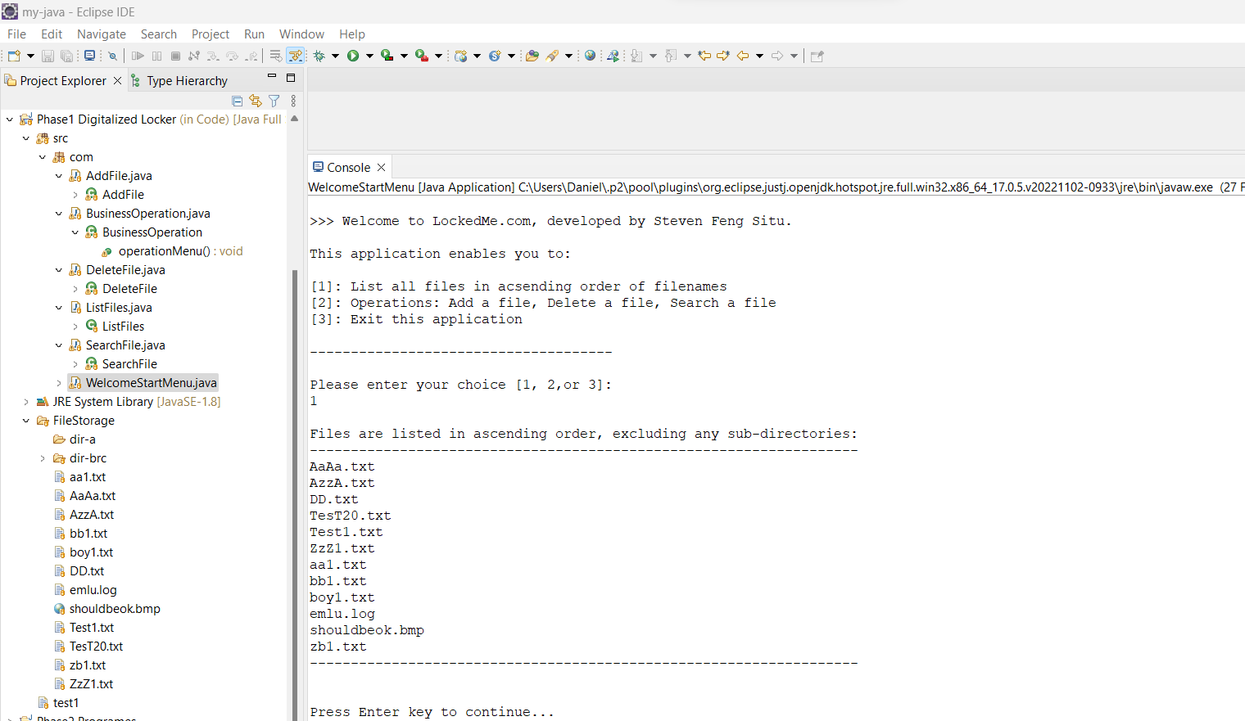

# Conclusion on enhancing the application and defining the Unique Selling Points

**- Simplified and informative User Interface**

**- Secured with Java native encapsulation**

**- Maximize code re-using inside**

**- Clear and scalable code structure for future function/feature addition**

**Continue in next page for Flow Chart >>>**

# Flowchart

Welcome Landing Menu

Option1, List filenames in ascending order

Option2, Business Operation...

Option3, Exit the application

Read Option

Option in [1,2,3]?

Err:retry

No

Yes

Option=1,   
 List filenames

Yes

No

List filenames ascending

Option=2,   
 BS.Operation...

Yes

No

Option=3,   
 Exit application

Exit application

BS Operations Menu

Opr1, Add file

Opr2, Delete file

Opr3, Search file

Opr4, Return to Welcome Menu

Opr=1,   
 Add file

Yes

Add file Operation

No

Opr=2,   
 Delete file

Read Op.

Delete file Op.

Yes

Opr=3,   
 Search file

No

Search file Op.

Yes

Opr=4,   
 Return to Welcome

Yes

No

No

No

Yes

No